**MILESTONE 4**

**Project : Financial Dashboard**

### 1. Introduction

#### 1.1 Purpose of the Dashboard

The dashboard provides a comprehensive analysis of financial performance across regions, categories, and time periods. It supports decision-makers by presenting trends, optimizing resources, and evaluating key performance indicators (KPIs) for strategic planning and business growth.

#### 1.2 Dataset Overview

The dataset includes transactional data from 2018 to 2023, comprising over 50,000 entries. Key columns are:

* **Sales Amount**
* **Profit**
* **Category**
* **Region**
* **Date**

These attributes allow for multidimensional analysis of financial metrics.

#### 1.3 Key Features

* Interactive visualizations for actionable insights.
* Dynamic filtering and cross-highlighting.
* Real-time data updates (if applicable).

### ****2. DAX Functions****

### ****1. Aggregate Functions****

#### ****1.1 Total Sales****

* **Purpose**: Calculates the total revenue generated from sales.

Total Sales = SUM(Sales[Amount])

* **Explanation**:
  + The SUM function adds up all the values in the Amount column of the Sales table.
  + Used in KPI cards, bar charts, or trend analyses.

#### ****1.2 Total Profit****

* **Purpose**: Computes the overall profit by summing up the profit column.

Total Profit = SUM(Sales[Profit])

* **Explanation**: Similar to Total Sales but applied to the Profit column.

### ****2. Ratio and Percentage Calculations****

#### ****2.1 Profit Margin****

* **Purpose**: Calculates profit as a percentage of sales.

Profit Margin = DIVIDE(SUM(Sales[Profit]), SUM(Sales[Amount]), 0)

* **Explanation**:
  + The DIVIDE function divides the total profit by the total sales.
  + The third argument 0 ensures no errors occur if sales are zero.
  + Displayed in KPI cards or visualizations for profitability analysis.

#### ****2.2 Contribution to Total Sales****

* **Purpose**: Computes the percentage contribution of each category/region to total sales.

Sales Contribution = DIVIDE(Sales[Amount], CALCULATE(SUM(Sales[Amount]), ALL(Sales)))

* **Explanation**:
  + CALCULATE evaluates the total sales across all categories by removing filters using ALL.
  + Helps in identifying the share of each category/region.

### ****3. Time Intelligence Functions****

#### ****3.1 Year-to-Date Sales (YTD Sales)****

* **Purpose**: Aggregates sales from the beginning of the year to the current date.

YTD Sales = TOTALYTD(SUM(Sales[Amount]), Date[Date])

* **Explanation**:
  + TOTALYTD calculates the cumulative sum for a time period (e.g., calendar year).
  + Uses the Date table to track time progression.
  + Suitable for trend analyses or KPI comparisons.

#### ****3.2 Previous Year Sales****

* **Purpose**: Compares sales to the previous year for trend analysis.

Previous Year Sales = CALCULATE(SUM(Sales[Amount]), SAMEPERIODLASTYEAR(Date[Date]))

* **Explanation**:
  + SAMEPERIODLASTYEAR shifts the context to the same time period one year earlier.
  + Useful for year-over-year (YoY) growth tracking.

#### ****3.3 Monthly Sales Trend****

* **Purpose**: Calculates total sales for each month.

Monthly Sales = SUM(Sales[Amount])

* **Explanation**:
  + Context-sensitive: When used with a date hierarchy (Year → Month), it dynamically shows monthly totals.

### ****4. Logical and Conditional Functions****

#### ****4.1 Pass/Fail Indicator****

* **Purpose**: Categorizes students or transactions as "Pass" or "Fail" based on criteria.

PassFail = IF(Sales[Profit] > 0, "Pass", "Fail")

* **Explanation**:
  + The IF function checks whether profit is greater than zero.
  + Returns "Pass" for positive profits and "Fail" otherwise.

#### ****4.2 High Performer****

* **Purpose**: Flags regions or categories performing above average.

High Performer = IF(Sales[Amount] > AVERAGE(Sales[Amount]), "Yes", "No")

* **Explanation**:
  + Compares each record’s sales to the overall average.
  + Useful for highlighting outliers.

### ****5. Ranking and Filtering Functions****

#### ****5.1 Top 10 Products by Sales****

* **Purpose**: Identifies the top 10 products based on sales.

Top Products = RANKX(ALL(Sales[Product]), SUM(Sales[Amount]), , DESC)

* **Explanation**:
  + RANKX assigns a rank to each product based on total sales.
  + Sorting order is specified as descending (DESC).

#### ****5.2 Filtered Total Sales****

* **Purpose**: Sums sales for a specific category or region.

Filtered Sales = CALCULATE(SUM(Sales[Amount]), Sales[Category] = "Electronics")

* **Explanation**:
  + CALCULATE modifies the filter context to include only records where the category is "Electronics."

### ****6. Advanced Metrics****

#### ****6.1 Average Sales Per Region****

* **Purpose**: Calculates the average sales for each region.

Average Sales = AVERAGE(Sales[Amount])

* **Explanation**:
  + Simple aggregation using the AVERAGE function.
  + Provides insights into regional performance.

#### ****6.2 Score Improvement****

* **Purpose**: Tracks improvement percentage between two metrics (e.g., sales from two periods).

Score Improvement = DIVIDE(Current - Previous, Previous, 0)

* **Explanation**:
  + Calculates the percentage change between two metrics.
  + Helps in identifying growth or decline.

### 3. Page Descriptions

#### 3.1 Page 1: Overview

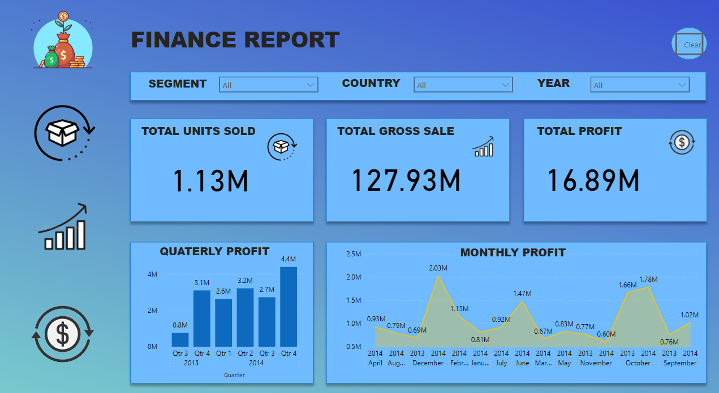

**Visuals**:

* 1. **KPI Cards**: Total Sales, Total Profit, Average Sales, Profit Margin.
  2. **Bar Chart**: Sales by Category.
  3. **Line Chart**: Monthly Sales Trend.
  4. **Slicer**: Region and Year.

**Insights**:

* + Sales exceeded $5M in the last fiscal year, with 10% year-over-year growth.
  + Electronics contributes 45% of revenue.
  + Seasonal peaks occur in Q4.

**Interactivity**:

* + Slicers adjust data by region/year.
  + Cross-filtering enabled.

#### 3.2 Page 2: Regional Analysis

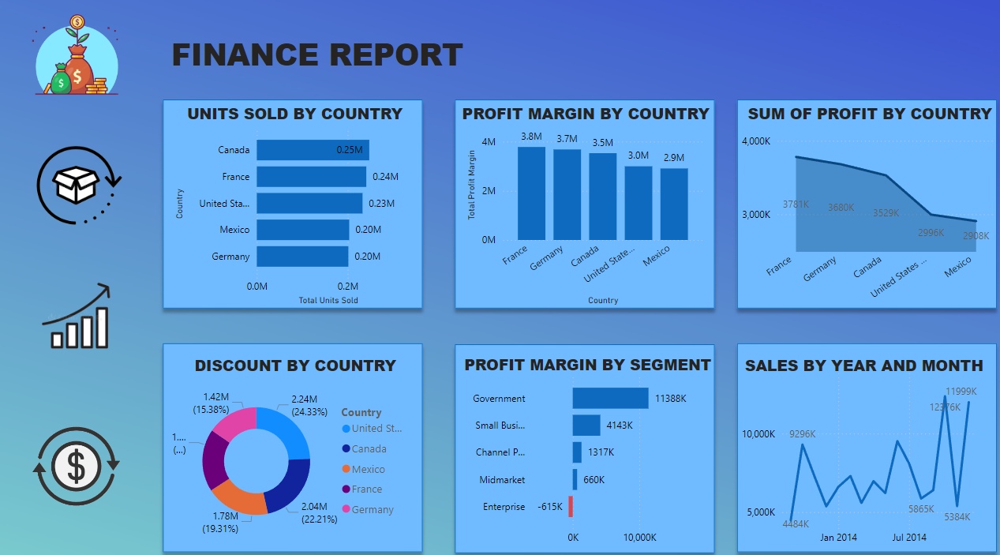

**Visuals**:

* 1. **Map**: Sales and profit by region.
  2. **Clustered Bar Chart**: Profit by Region.
  3. **Pie Chart**: Sales Contribution by Region.

**Insights**:

* + East region has high revenue but lower margins.
  + Central region underperforms.
  + South region shows growth potential.

**Interactivity**:

* + Filters based on map selection.

### 4. Conclusion

The Financial Dashboard offers executives a powerful tool to evaluate trends, compare regional performance, and optimize strategies. By leveraging its interactive features, businesses can drive informed decisions for growth and profitability.